Visionbay.ai Announces Strategic Partnership with SAP
To Accelerate AI-Powered Manufacturing and Supply Chains for global deployment
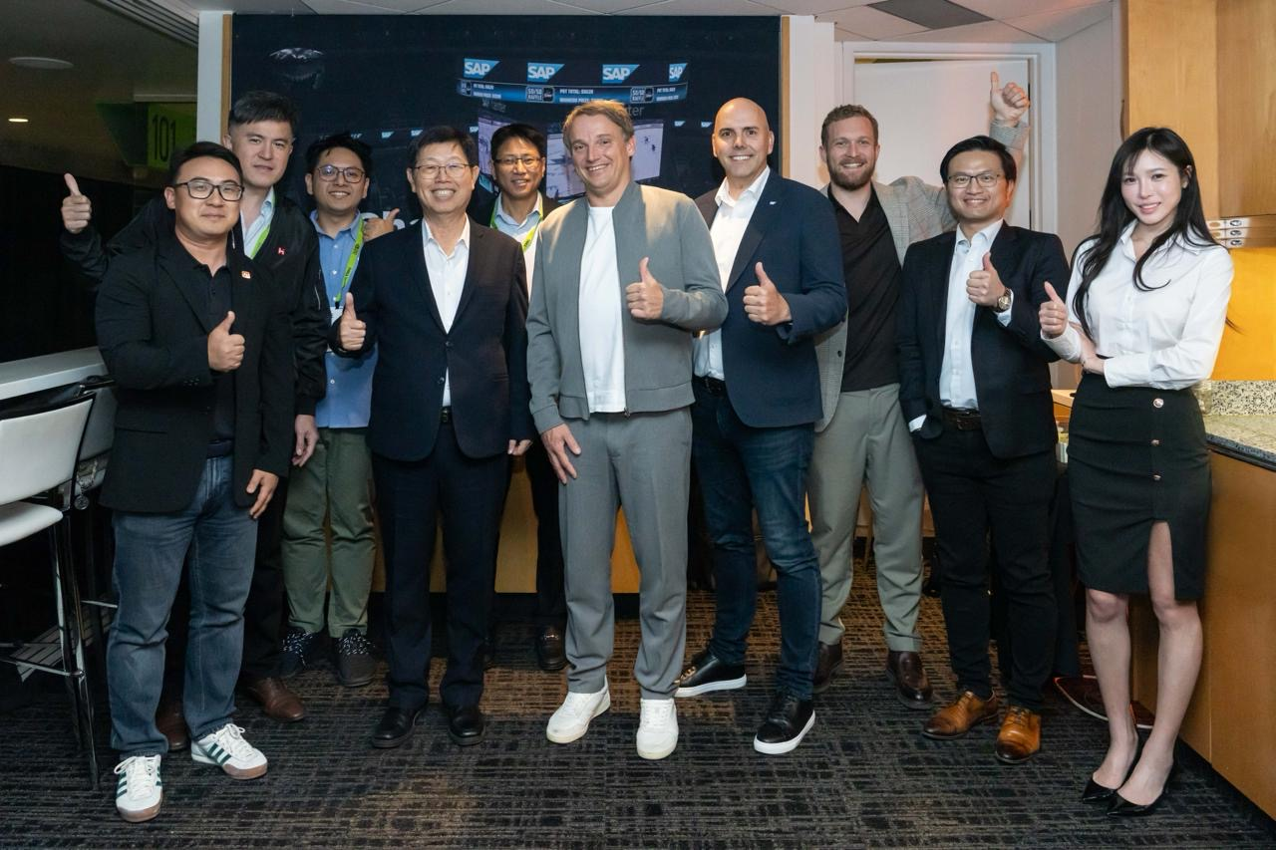
【16 March 2026, San Jose, California, and Taipei, Taiwan】 Hon Hai Technology Group (“Foxconn”) (TWSE:2317) plans to accelerate the adoption of next generation enterprise AI across the Asia-Pacific (APAC) region in strategic partnership with SAP SE, a global leader in enterprise applications and business AI.
The partnership, announced at NVIDIA GTC 2026 in San Jose, builds on Foxconn’s ongoing AI Factory initiative, aimed at reshaping the future of manufacturing processes and supply chain management and opening new pathways for global deployment.
With this partnership, Foxconn and SAP will bring together their respective technologies to help accelerate go-to-market initiatives across the APAC region and advance the deployment of AI technologies that support Foxconn’s journey toward becoming a fully digitized and AI-empowered organization. The companies will also explore new co-innovation use cases for Physical AI, SAP Supply Chain Management, and Foxconn Smart Manufacturing.

“Our strategic partnership with SAP is an important step toward realizing the vision of intelligent and AI-powered manufacturing,” said Young Liu, Chairman of Foxconn. “By bringing together Foxconn’s AI computing capabilities with SAP’s expertise in enterprise applications, we are addressing one of the most complex challenges facing global industries today.”
“AI is advancing at an unprecedented pace, and our partnership with Foxconn represents a powerful opportunity to accelerate enterprise AI adoption across the Asia-Pacific region," said Christian Klein, CEO of SAP SE. “Together, we are helping organizations harness technology that helps them move faster, operate more efficiently, and scale with confidence as they transform in the AI era.”
Looking ahead, Foxconn aims to work with SAP to help redefine how industries harness enterprise AI. By bringing together enterprise intelligence, AI infrastructure, and new pathways for real-world industrial deployment, the collaboration aims to establish a new blueprint for AI-powered manufacturing.

About Visionbay.ai
Visionbay.ai is one of the Taiwan’s NVIDIA Preferred Cloud Partner (NCP) and the Hon Hai Technology Group’s dedicated business unit for supercomputing and cloud-AI operations. With a mission to empower Asia’s AI ecosystem, Visionbay.ai integrates national-level computing infrastructure with Hon Hai’s deep strengths in manufacturing, design, and supply-chain orchestration.
Its end-to-end AI Factory solutions span high-performance compute, cloud operations, supply-chain integration, AI model and tool development, and an AI App Store. Visionbay.ai helps enterprises accelerate digital and AI transformation while building a trusted and sustainable sovereign-AI ecosystem.
To learn more, visit www.visionbay.ai

